Title: **MicroLogix PLC Output Status Screen** Job: 6

Course: Introduction to Automation Unit: Introduction to PLC CLO: 1, 4

Name ____________________________ Grade _______ Date ______________

**Objectives**

1. Student shall understand the Allen-Bradley MicroLogix 1100 PLC status display.
2. Student shall be able to decipher the status of outputs using the status display of a MicroLogix 1100 PLC.

**Assessment**

Students shall demonstrate a comprehension of the objectives listed above by scoring a minimum of 75% on this shop job. Grading shall be based on the Introduction to PLC rubric.

**Instructions**

1. In RSLogix 500 Pro, configure, verify and download the following ladder logic.

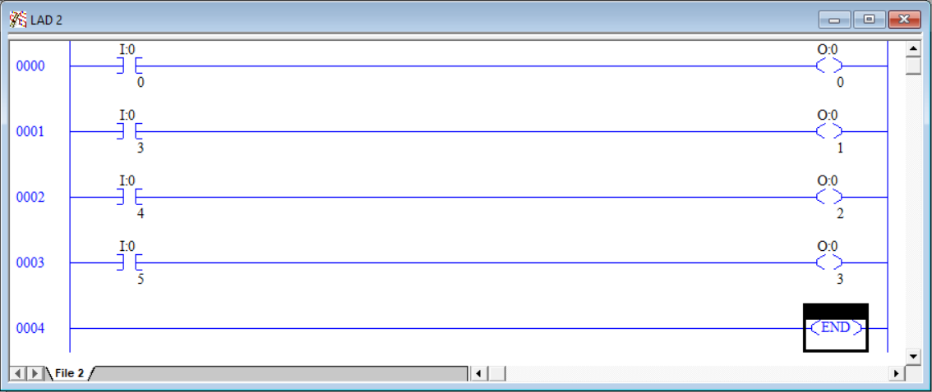

1. On the Main Menu screen of the MicroLogix 1100 PLC, use the up and down keys on the LCD keypad to locate the I/O Status Screen.
2. Press the OK button to select I/O Status.

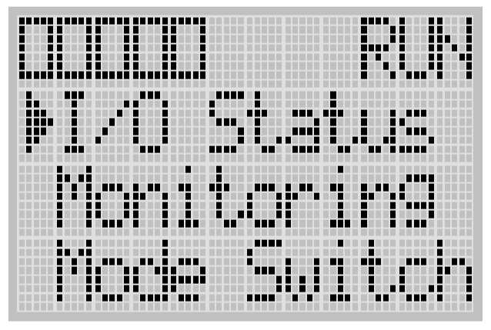

1. The I/O Status screen is displayed. (Status may differ from picture below)

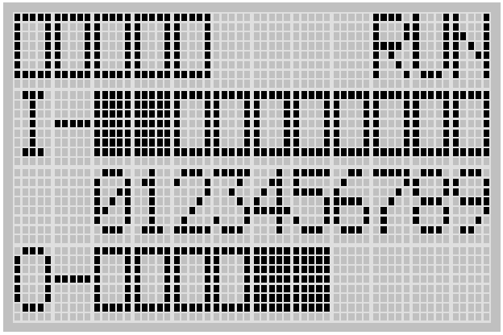

1. Place the noted inputs in the following conditions.
   1. ESTOP engaged (pushed in)
   2. Three-position selector switch in the center, OFF, position
   3. Two-position selector switch in the B position.

|  |  |
| --- | --- |
| The input and output status screen should look like the following; |  |

This output status screen is indicating that no outputs are energized and therefore should not have 24VDC present. Check voltages at outputs 0 through 3 and ensure they all have 0 VDC present. To test, measure from the DC- of the power supply (not the PLC as with the inputs). Record your findings below.

|  |  |  |  |  |  |
| --- | --- | --- | --- | --- | --- |
| O/0 | O/1 | O/2 | O/3 | O/4 | O/5 |
|  |  |  |  |  |  |

Even though the program that was downloaded only wrote to outputs 0 through 3, all six outputs are being set. If an output does not appear within the ladder logic, it will be set to FALSE which corresponds to 0VDC.

1. Disengage the ESTOP. Note the display and green pilot light. Measure and record for voltage at O/0. __________
2. Place the three-position selector switch in the A position. Note the status display and yellow pilot light. Measure and record the voltage at O/1 __________.
3. Place the three-position selector switch in the B position. Note the status display and yellow and red pilot lights. Measure and record the voltage at O/1 and O/2 __________.
4. Place the two-position selector switch in the A position. Note the status display and blue pilot light. Measure and record the voltage at O/3 ___________
5. Would it be possible to have a TRUE status on the PLC but not have an illuminated pilot light? If so, what would that indicate?

_________________________________________________________________________

1. Is it possible to output a source voltage other than 24VDC? _________________
2. If answered yes to question 10, how would this be accomplished?

_________________________________________________________________________